**DREAM HOME DATABASE ASSIGNMENT 4**

**CS 5332**

**FALL 2016**

**Instructor: PROF.DR.C.J.HWANG**

**DataBase: SQL Server Using SQL Server Management Studio**

**SUBMITTED TO: PROF.DR.C.J.HWANG SUBMITTED BY: ANUSHA VATTAM**

**TEXAS STATE ID: A04701078**

TABLE 1 BRANCH:

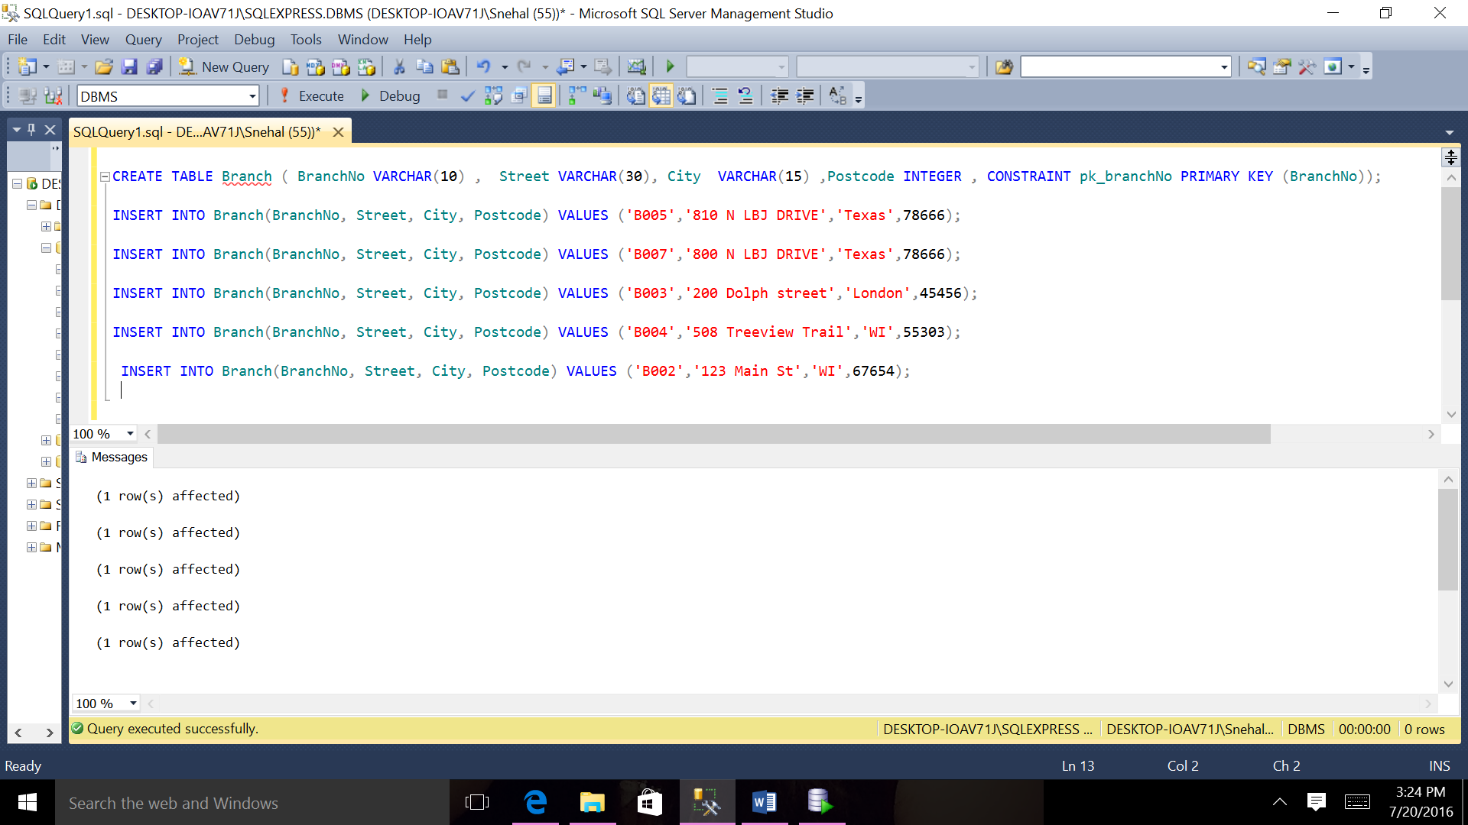

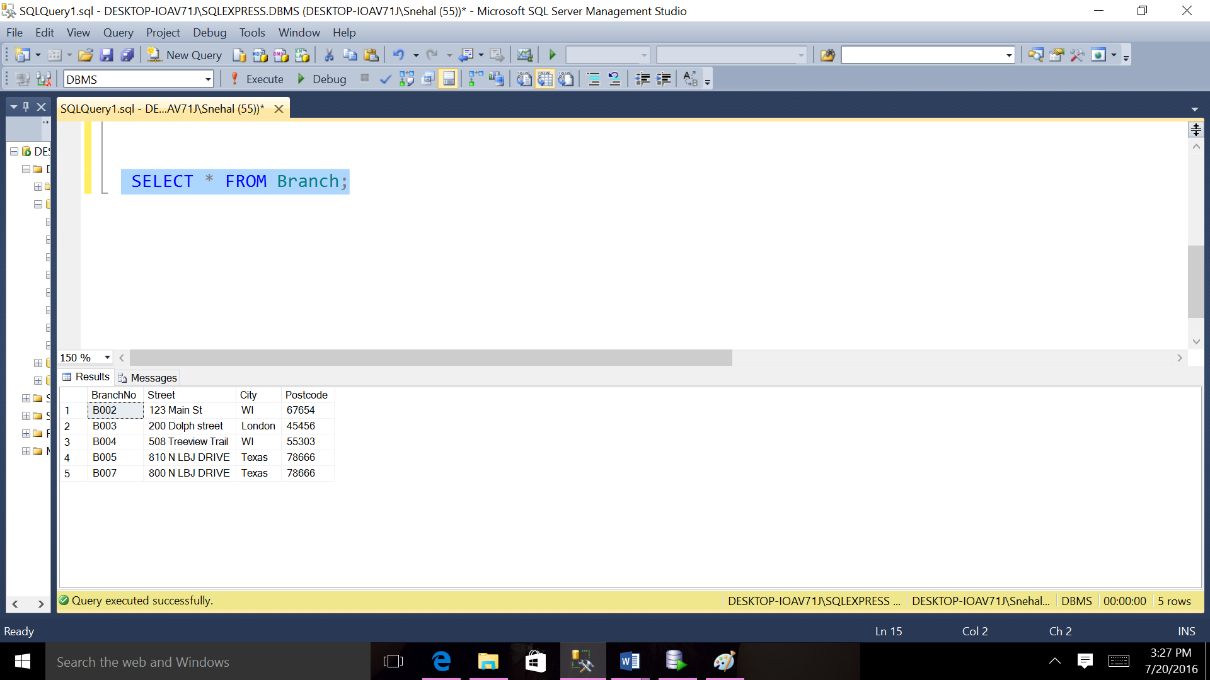

TABLE 2 STAFF

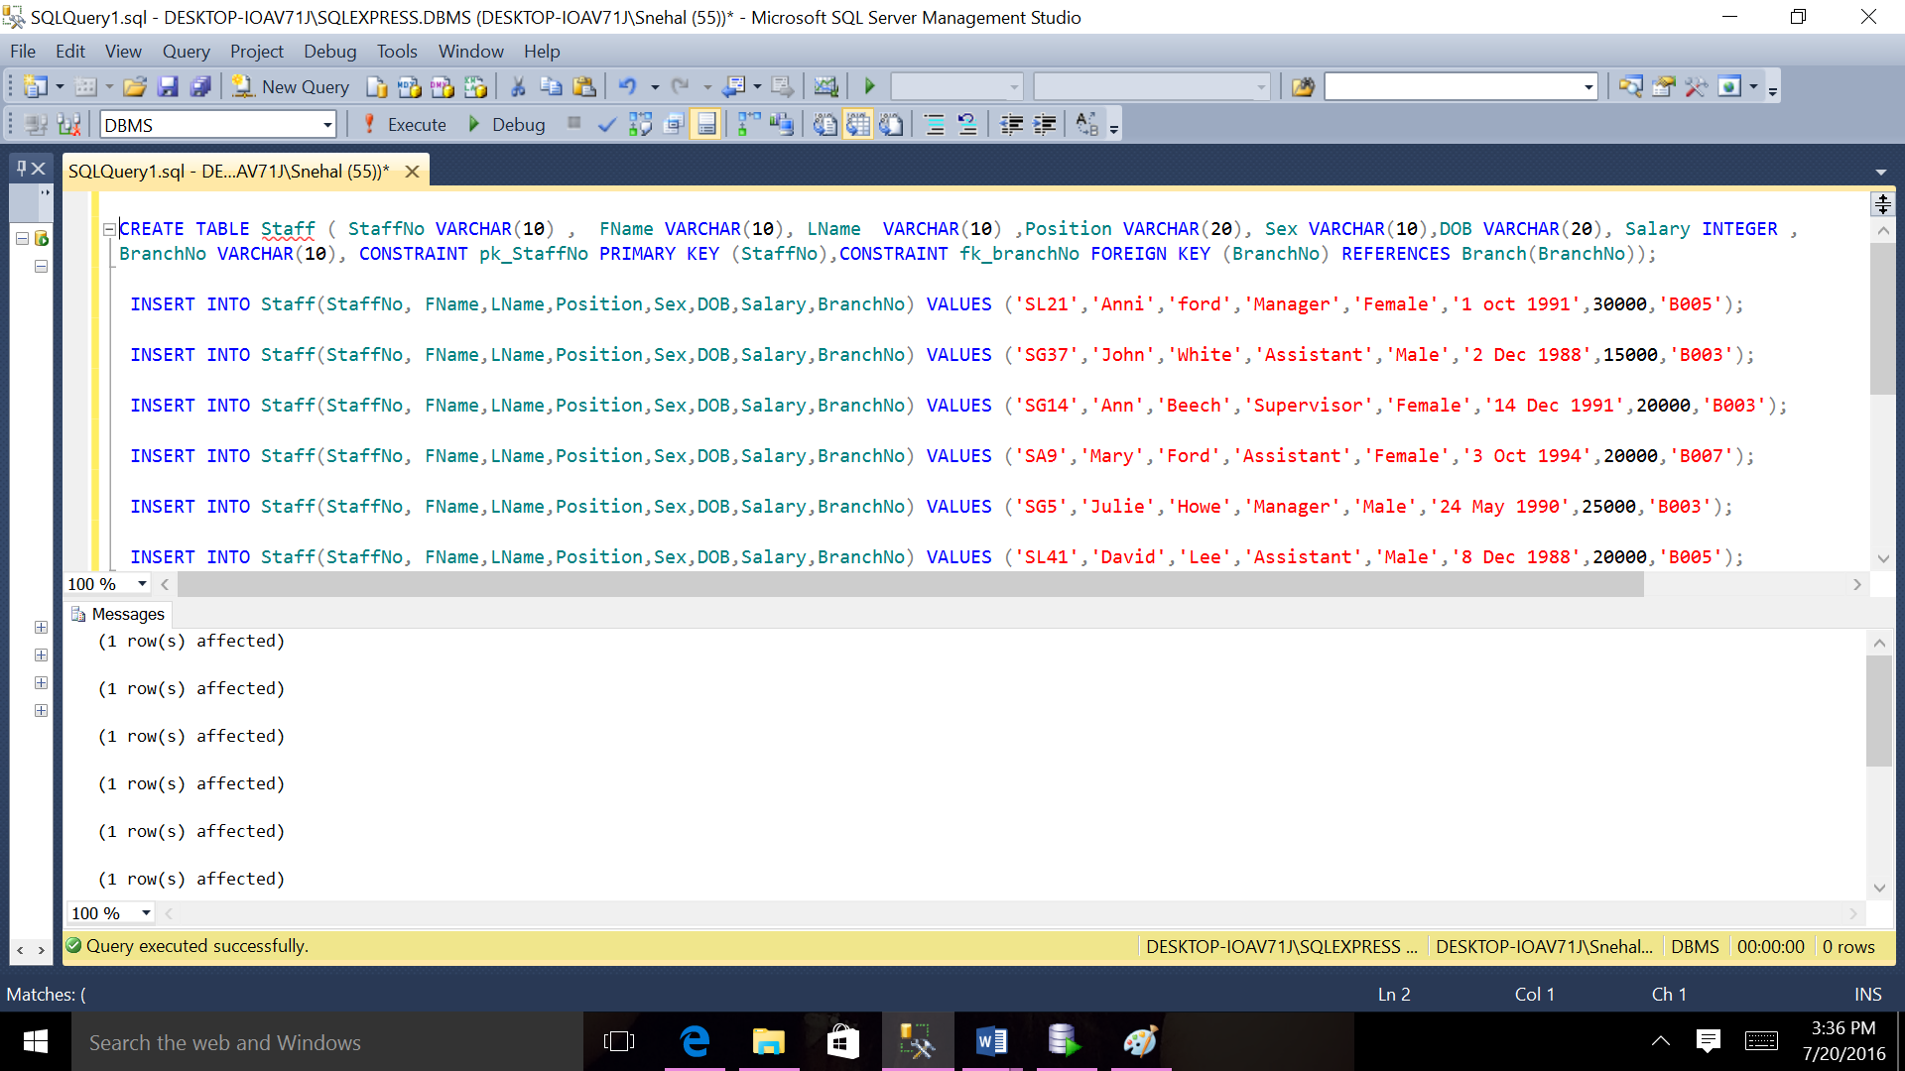

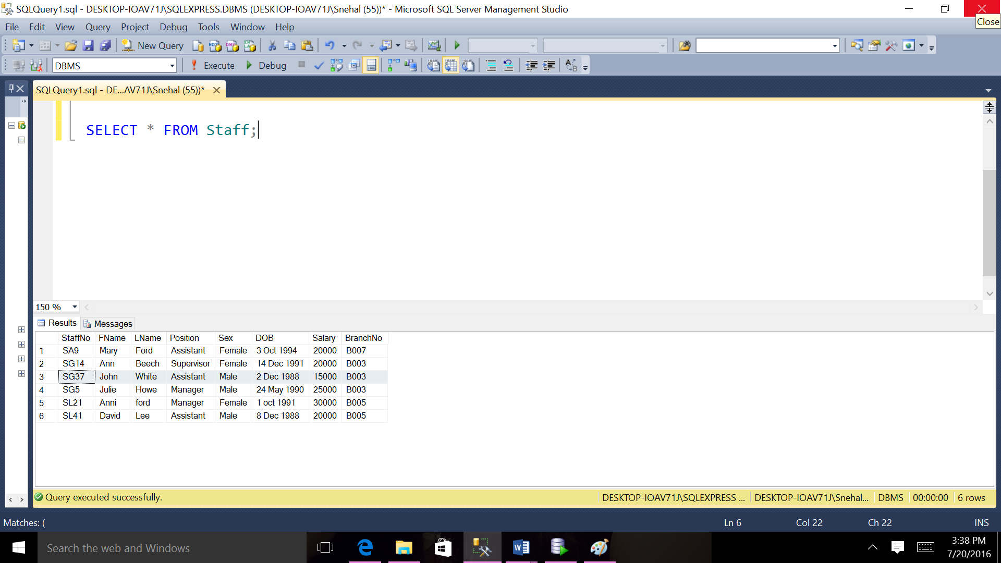

TABLE 3 PROWNER

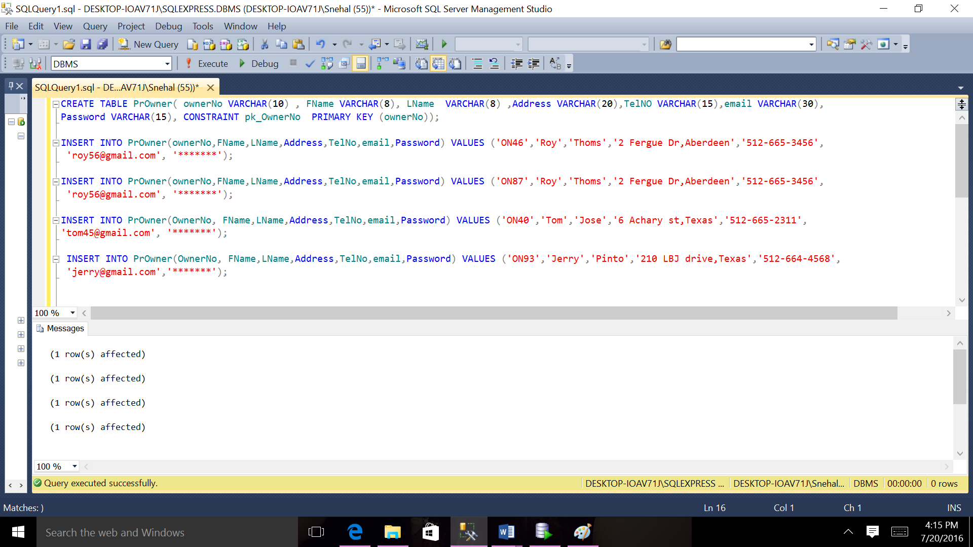

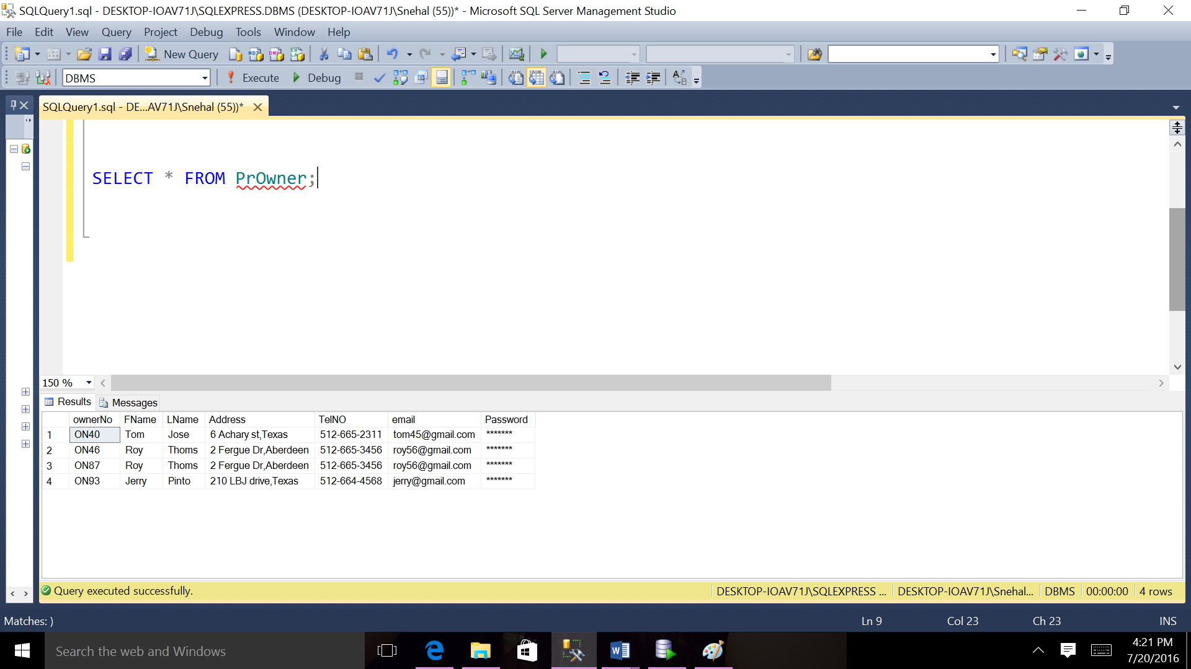

TABLE 4 PROPERTYFORRENT

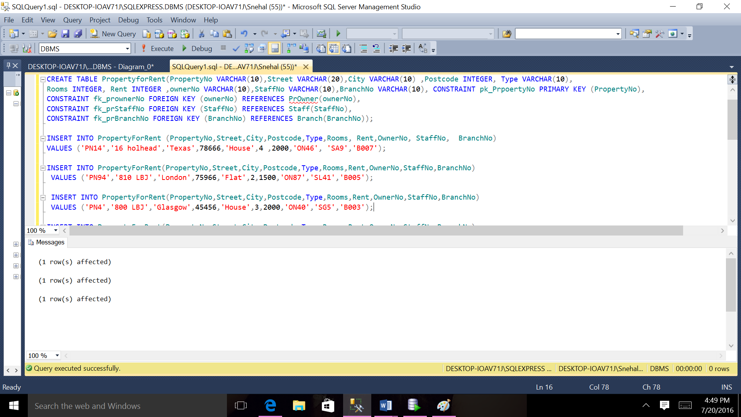

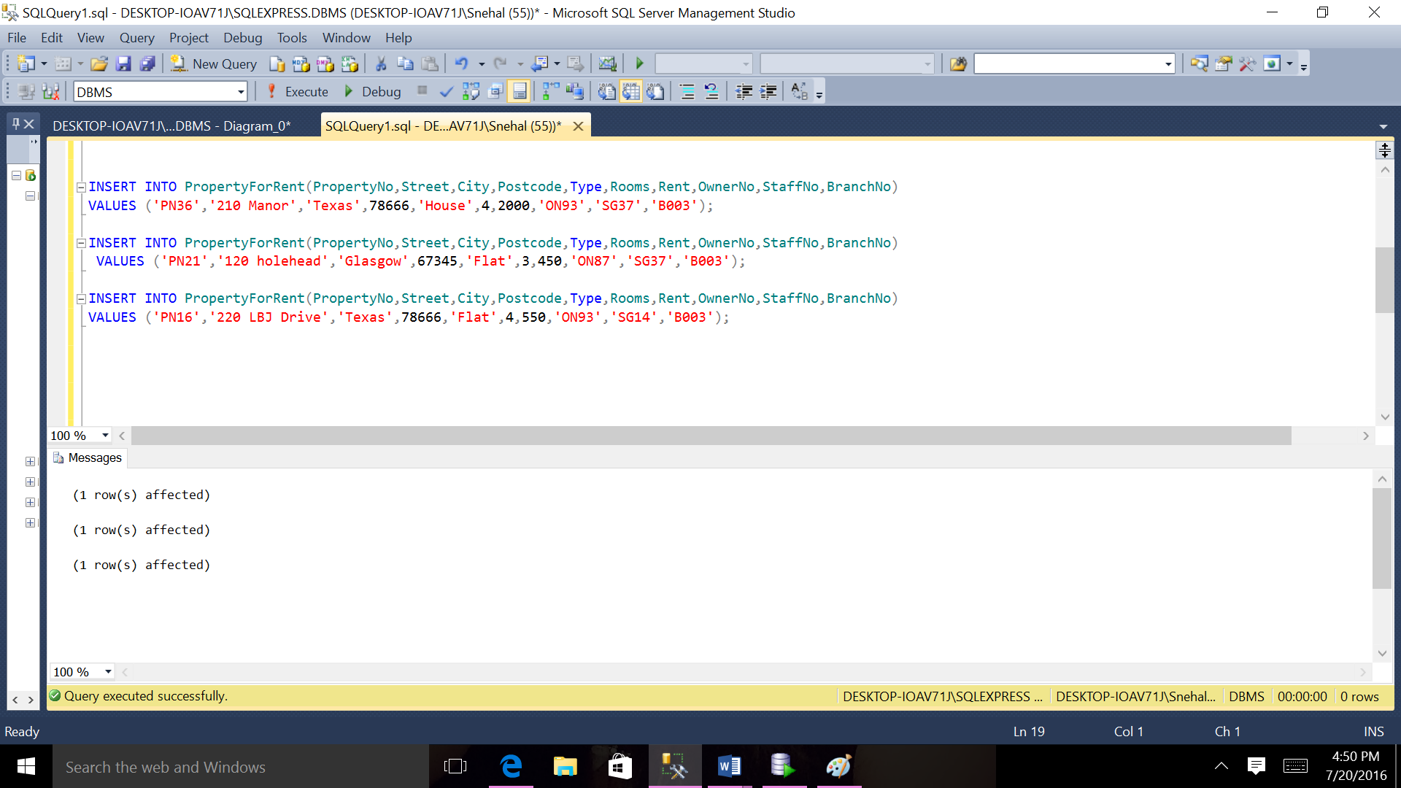

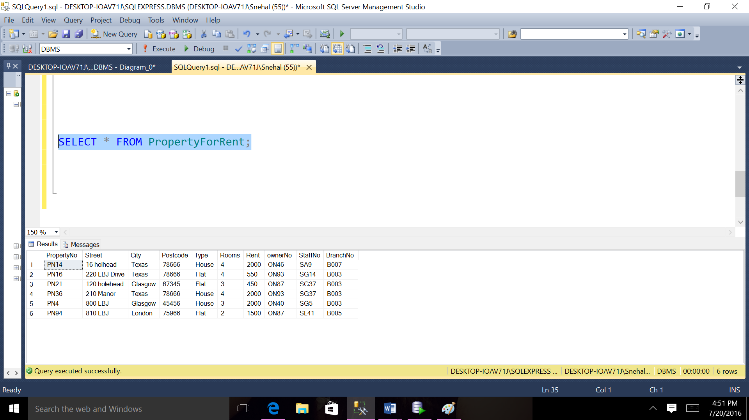

TABLE 5 CLIENT

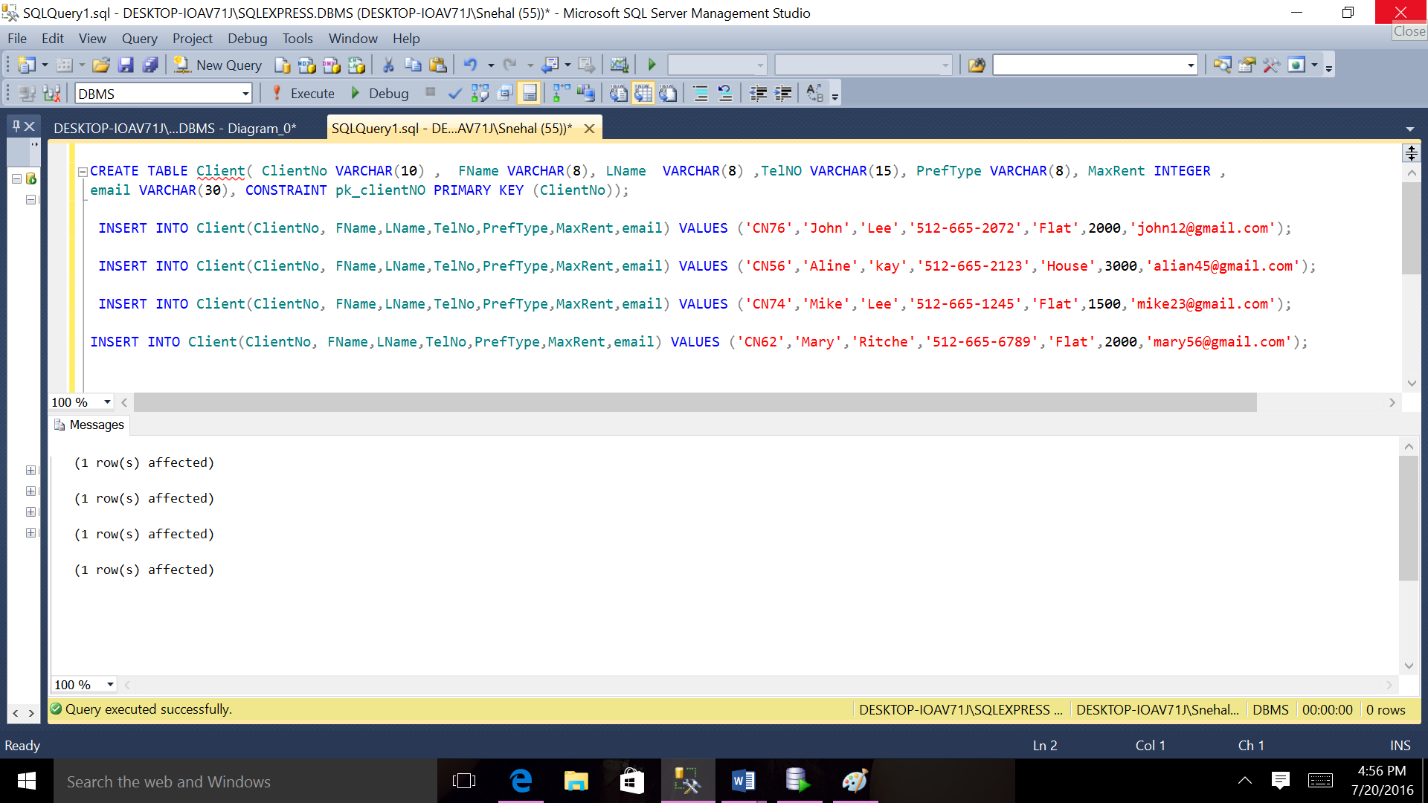

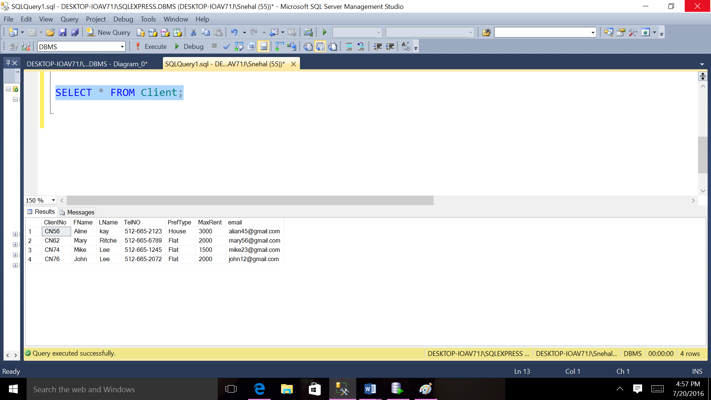

TABLE 6 VIEWING

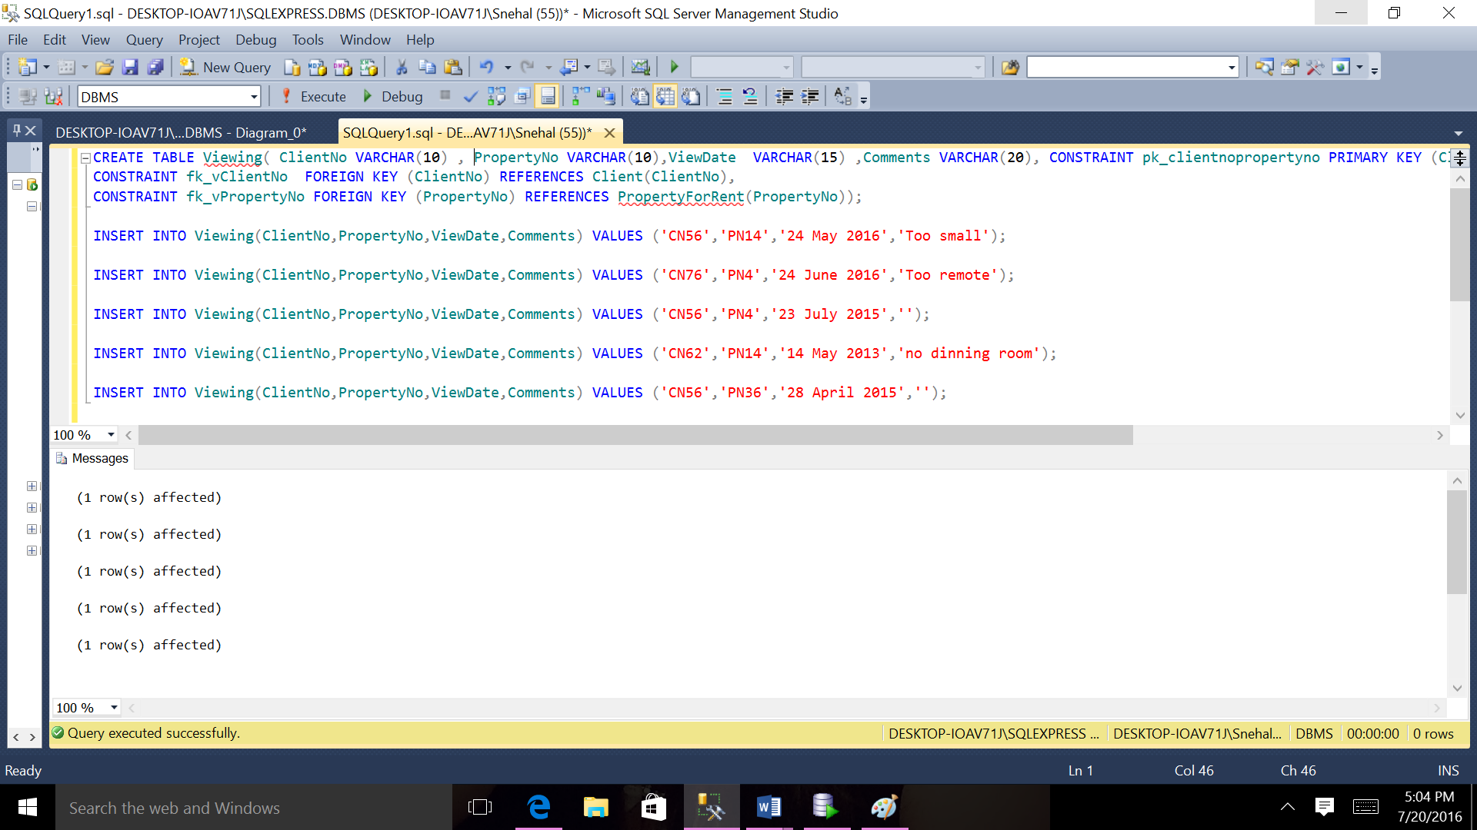

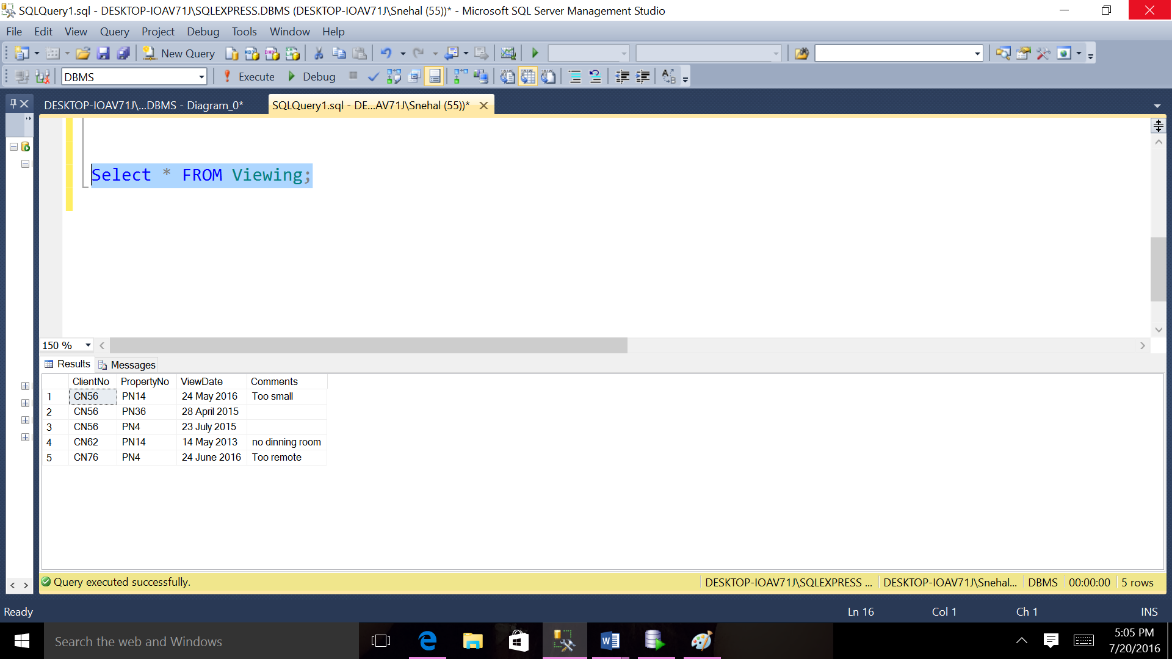

TABLE 7 REGISTRATION

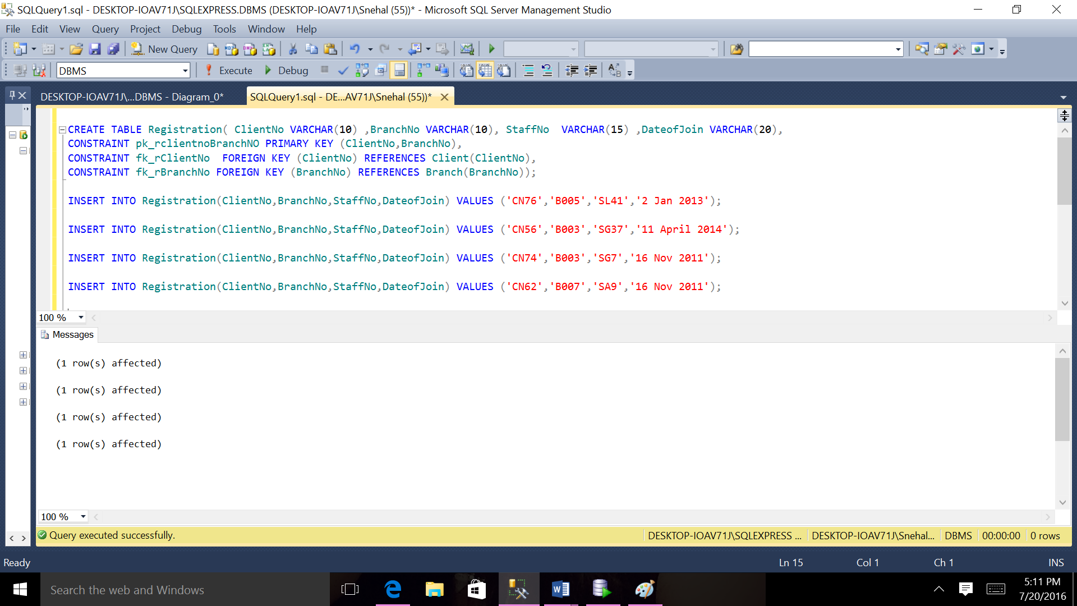

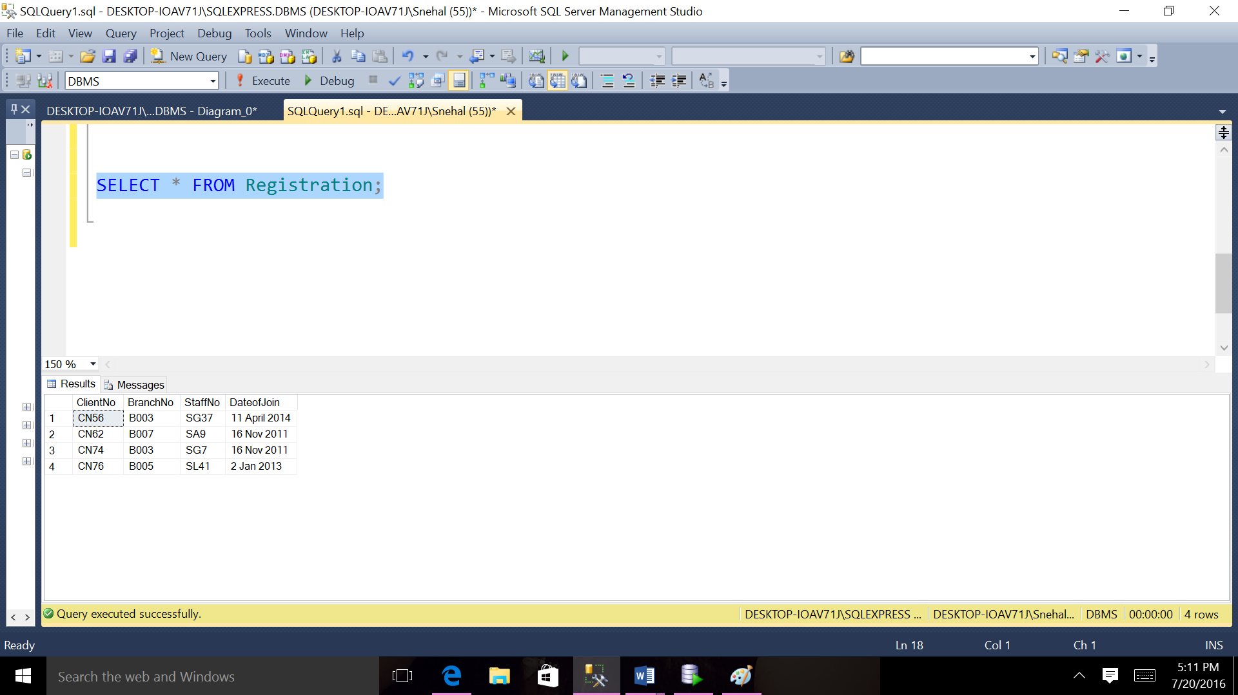

**QUERIES:**

1. **List all The Staff whose sex are same.**

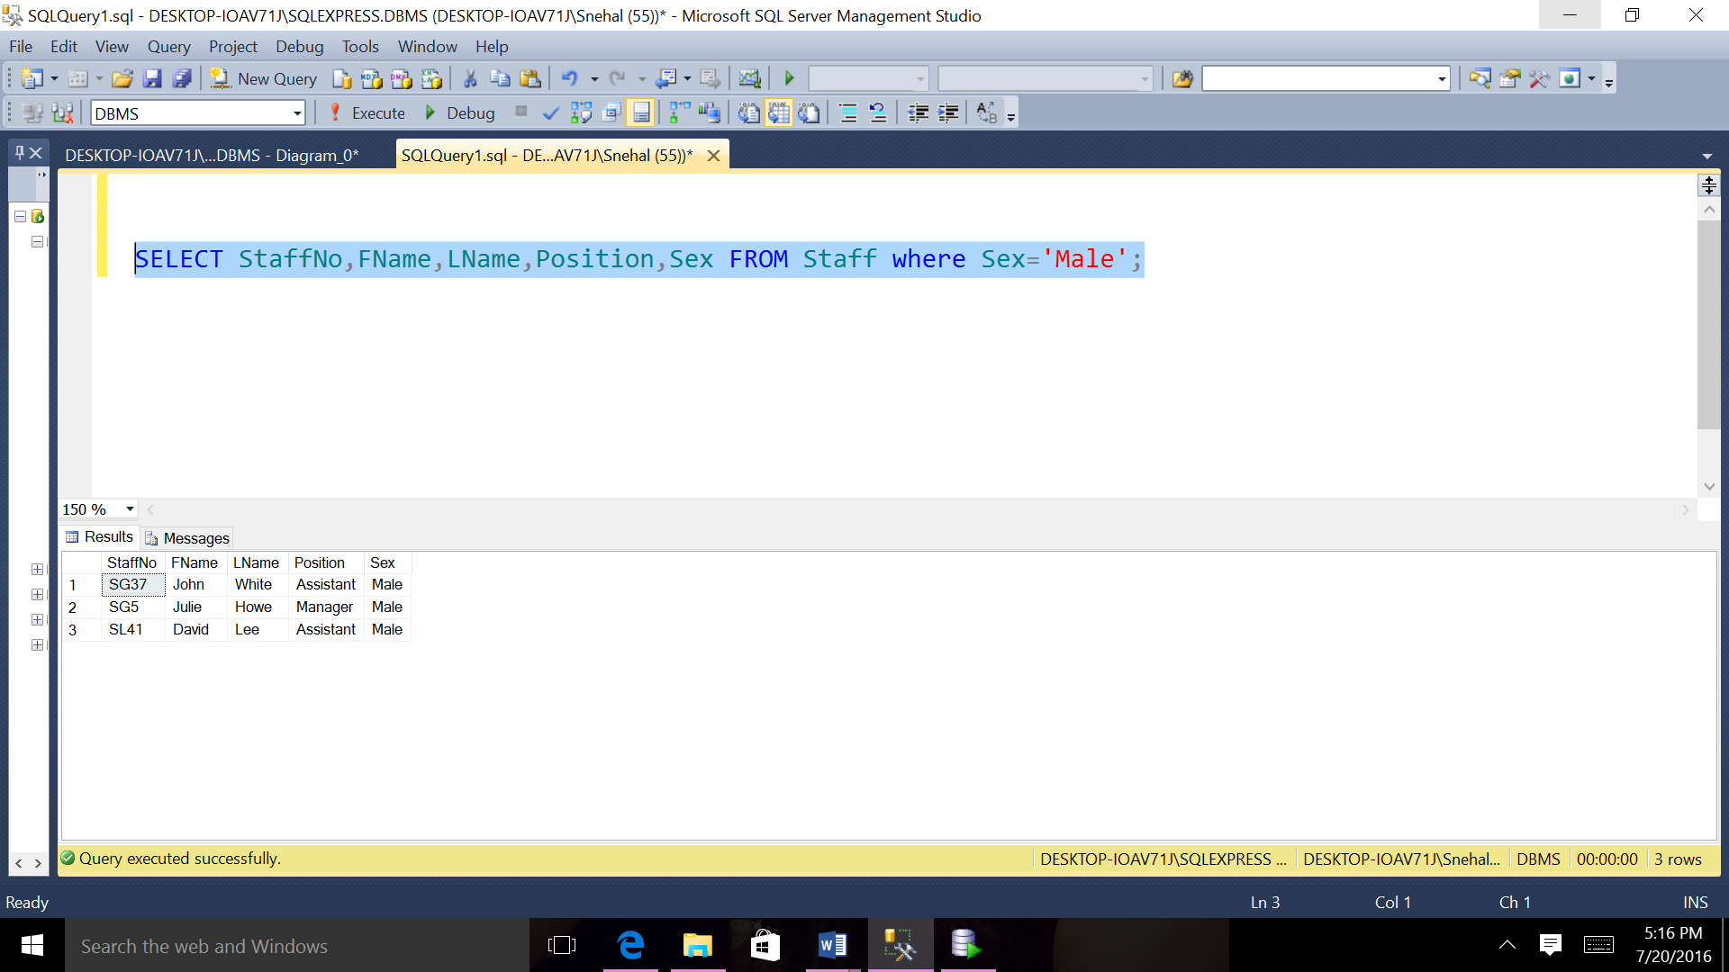

**2)Produce a list of salaries for all staff arranged in ascending order of salary.**

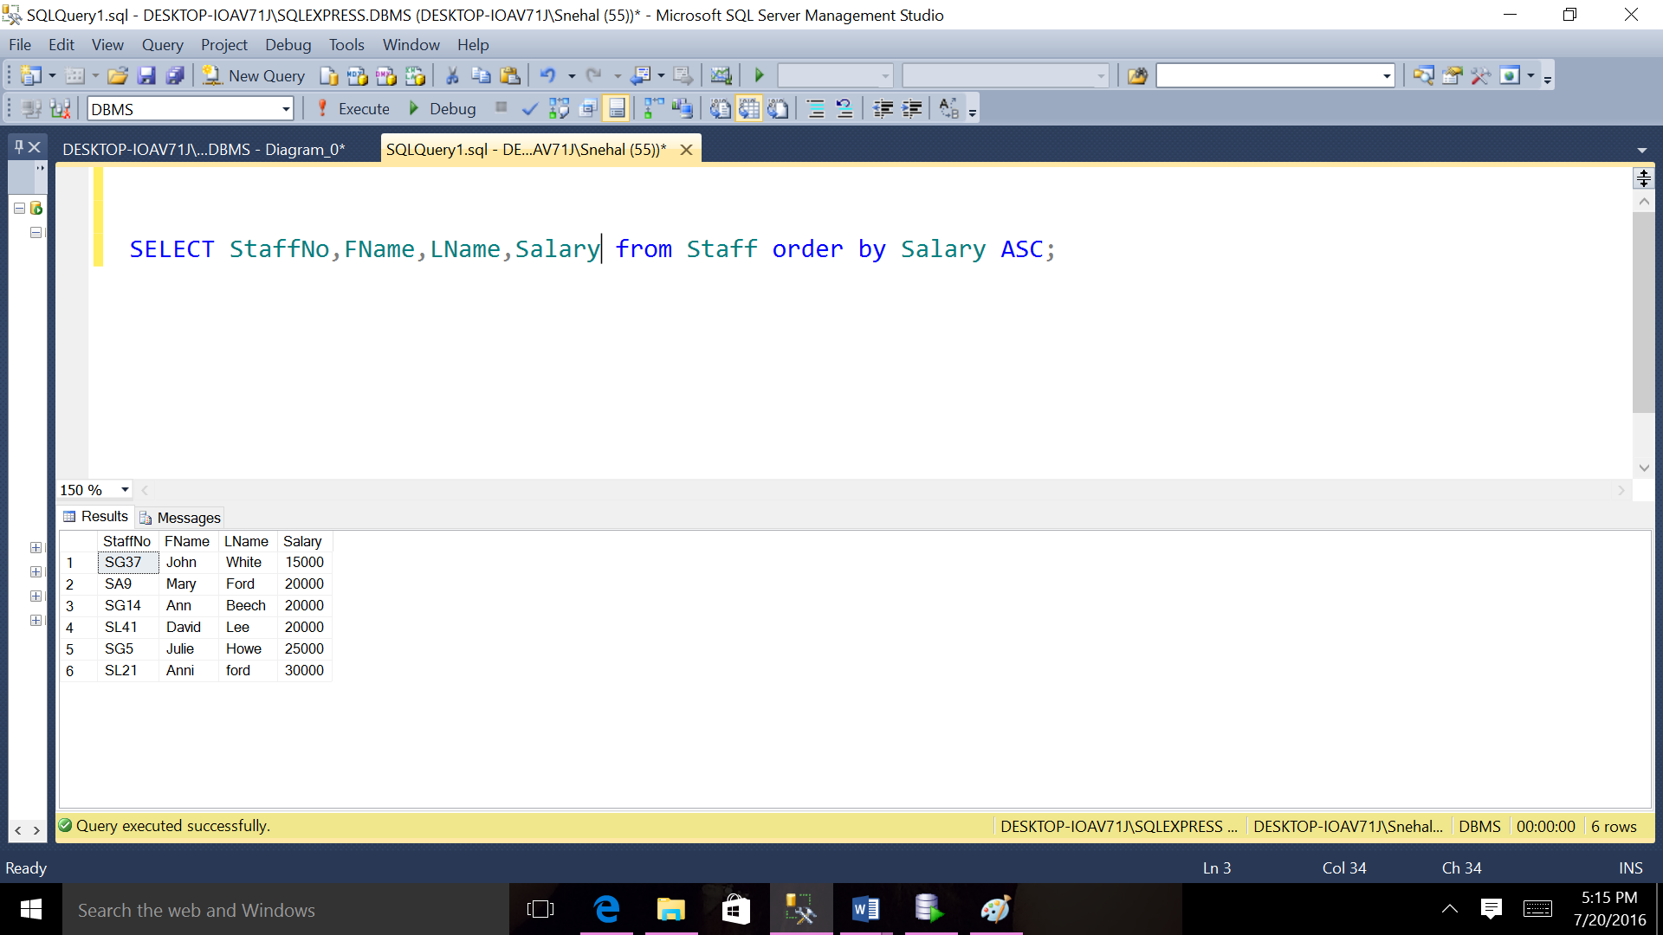

**3)List all The Client with a MaxRent greater than $1500.**

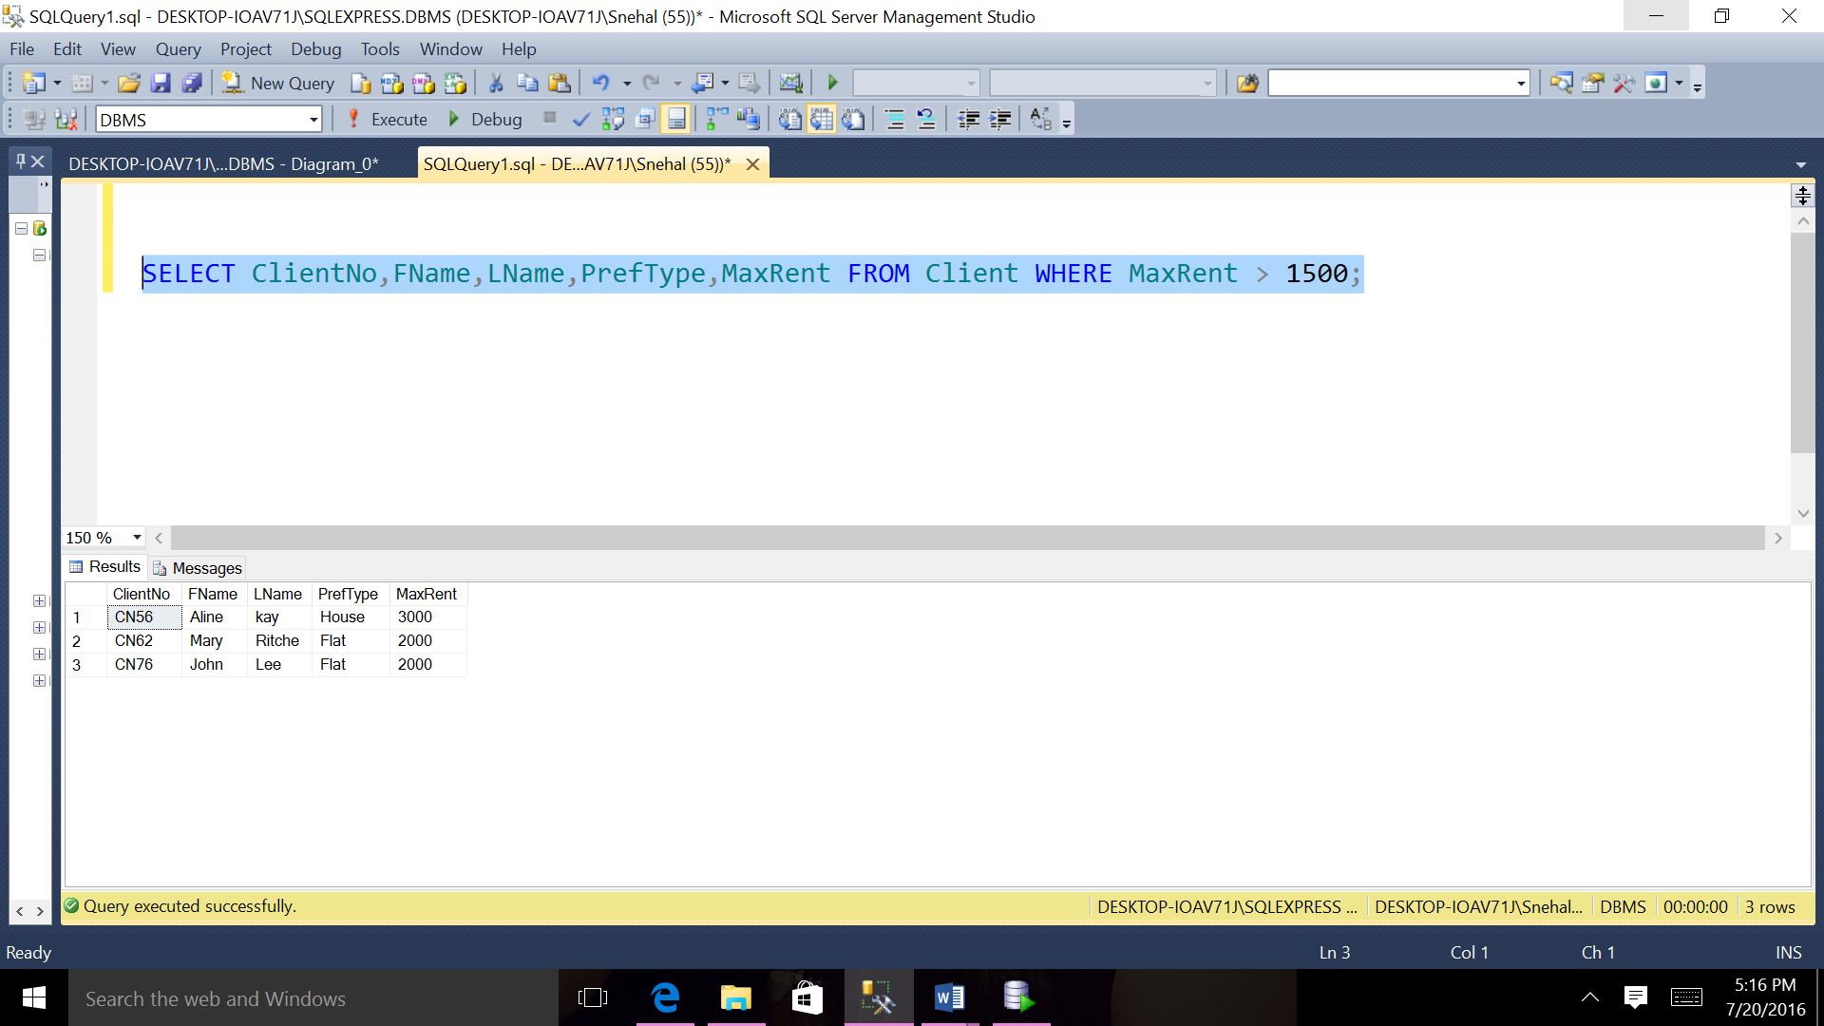

**5)List all the members of propertyForRent who has Owerno ON93 or City Texas.**

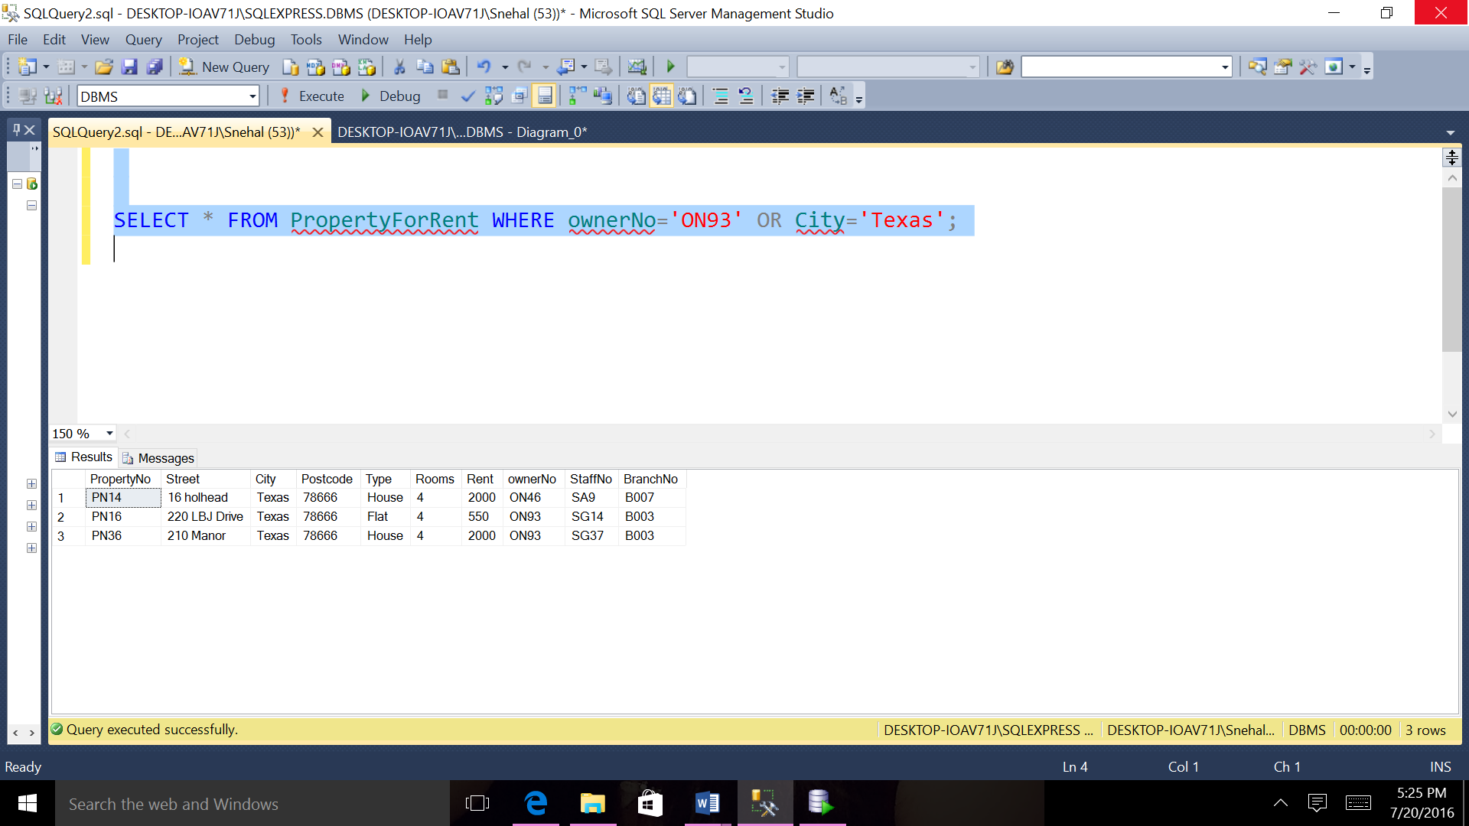

**6)List all The Type From PropertyForRent.**

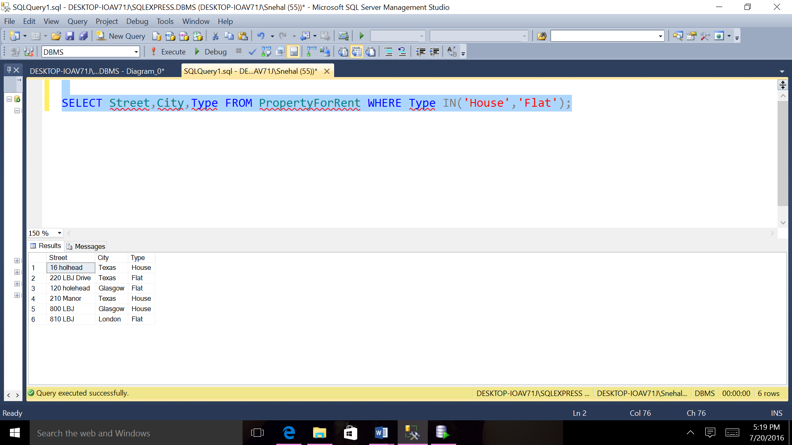

**7)Produce a list of ClientNo,PropertyNo,ViewDate for Viewing order by ClientNo.**

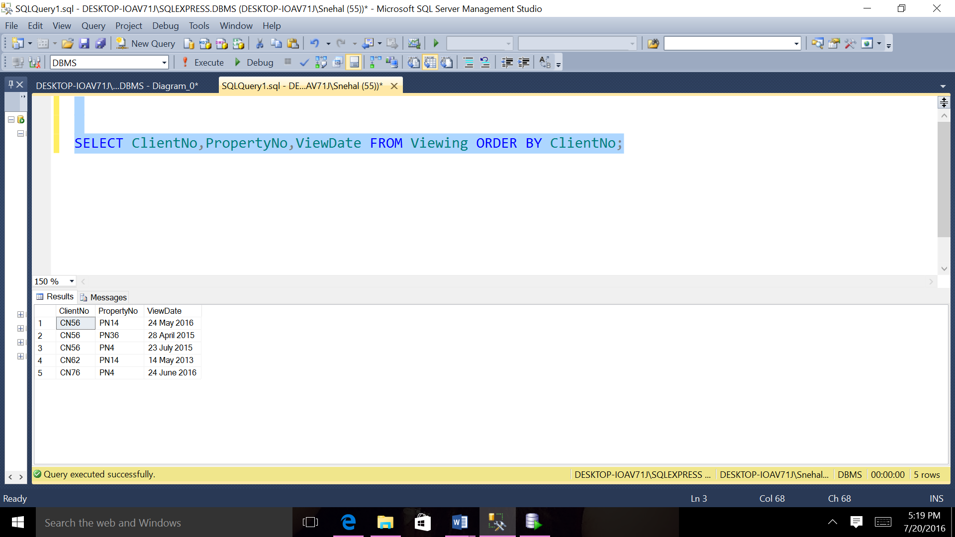

**8)Produce a list of dateofjoin for all client arranged in descending order of Dateofjoin.**

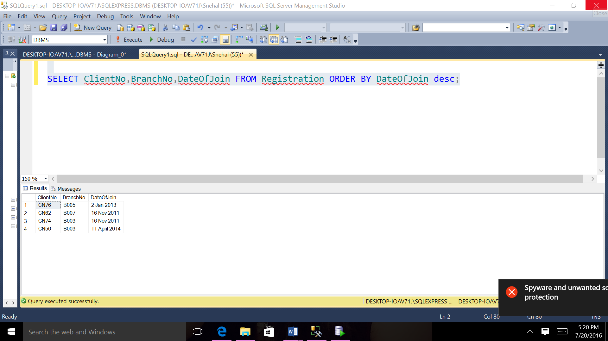

**9)List all the branchno,city and postcode who has Postcode 45456 or City Texas.**

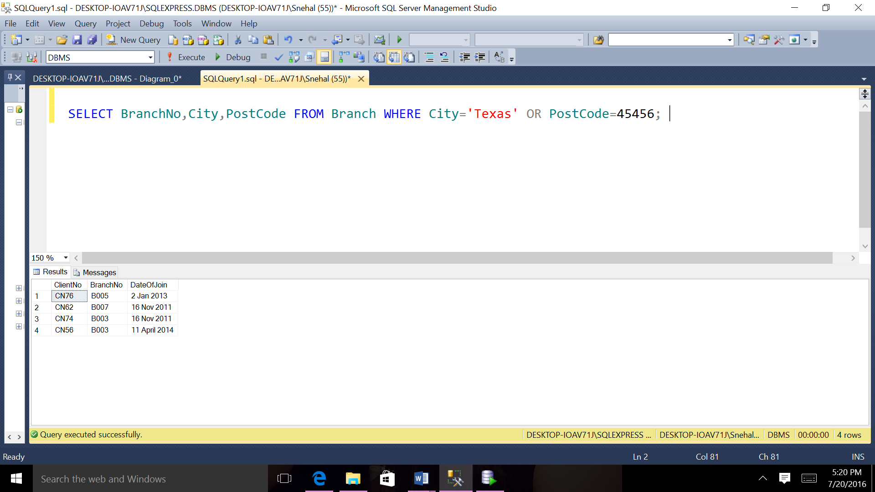

**10)Find all branch with the string ‘London’ in their city .**

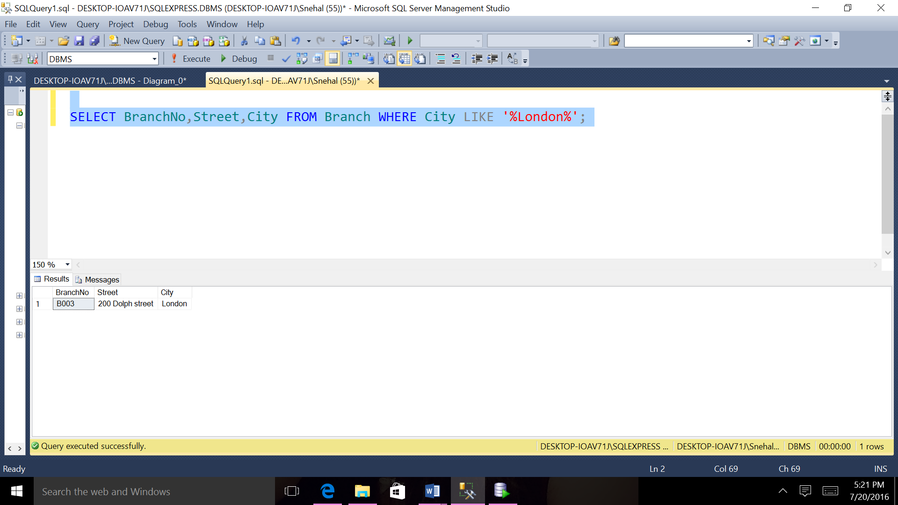

**12.List owerno and email from PrivateOwenr who has Fname roy and LName Thoms.**

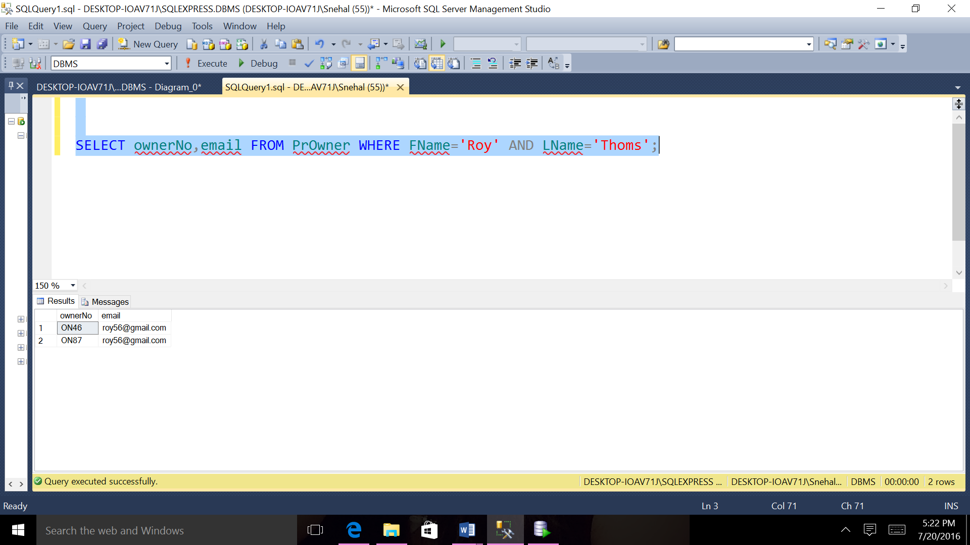

**13.List comments for viewing who has PropertyNo PN14.**

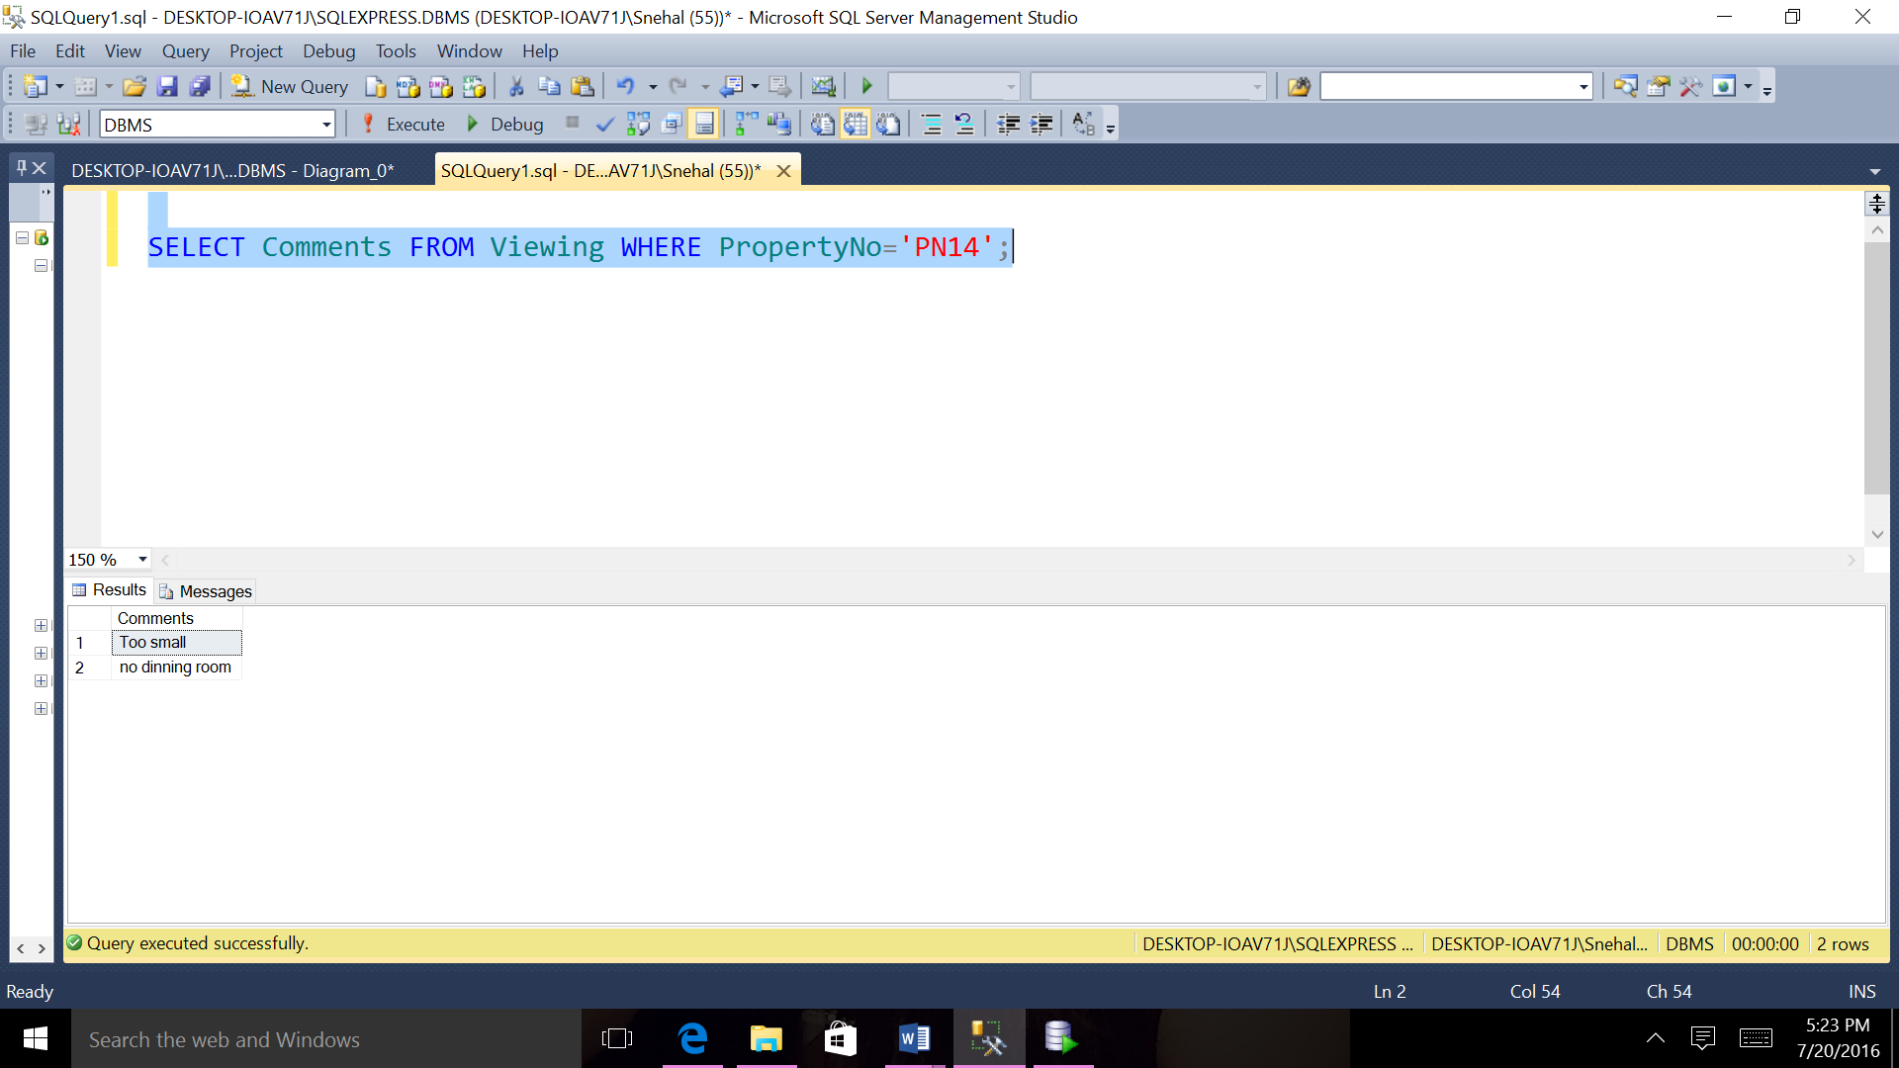

**14 Find the number of properties handled by each staff member,along with the branch no of the member of staff.**

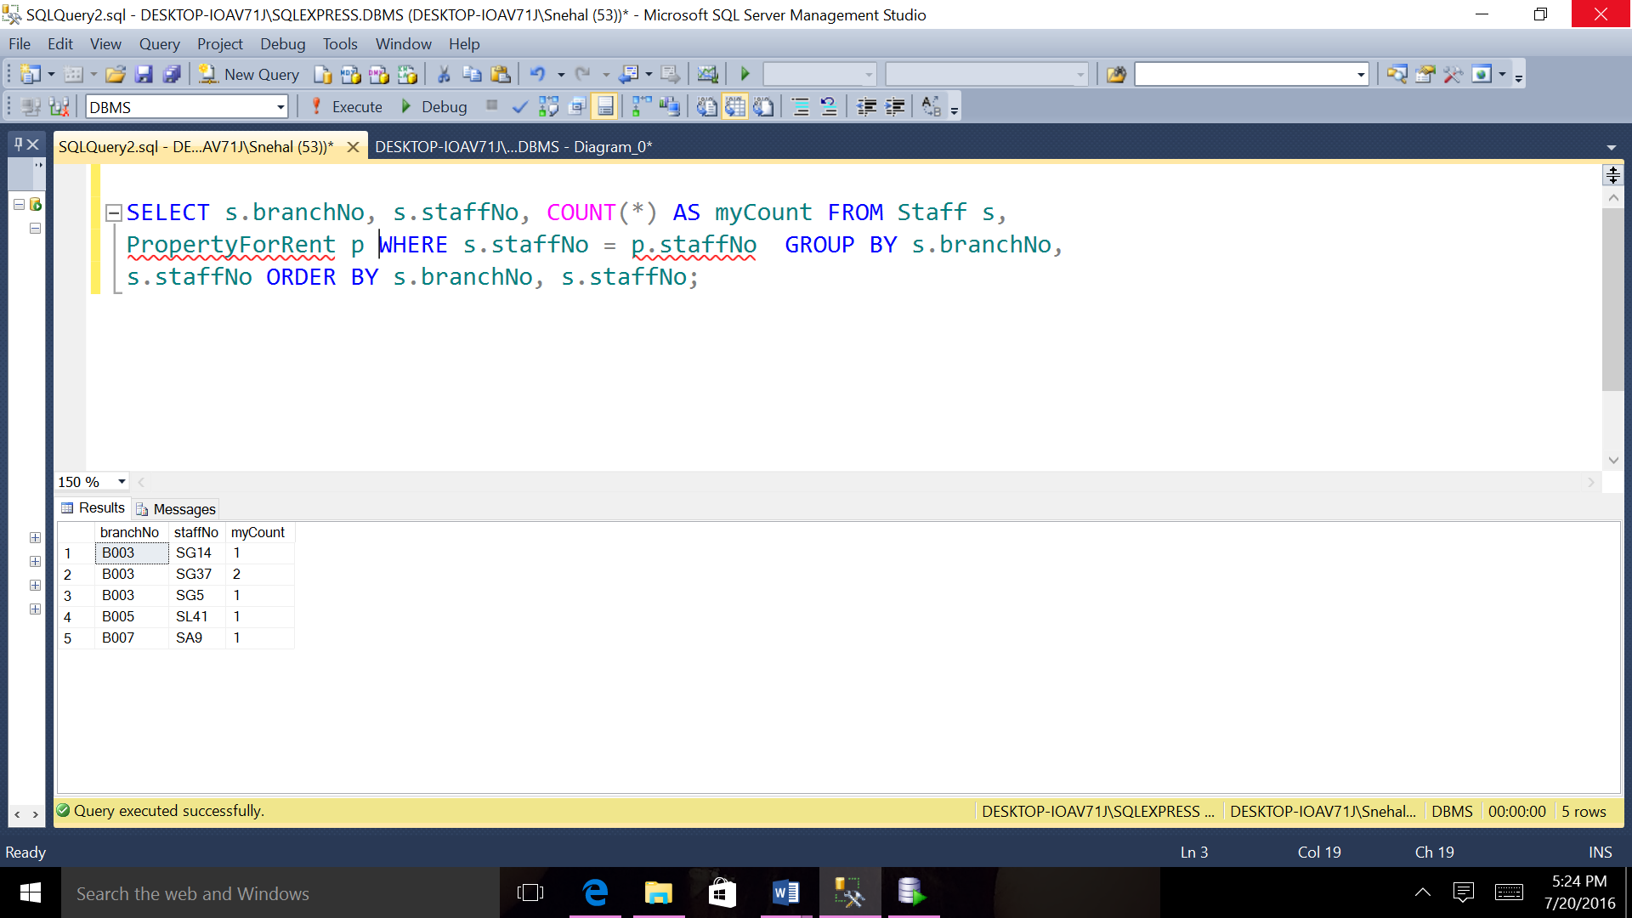

NATURAL JOIN QUERIES:

1. Select PrOwner for all PropertyForRent where rooms are greater than 2.

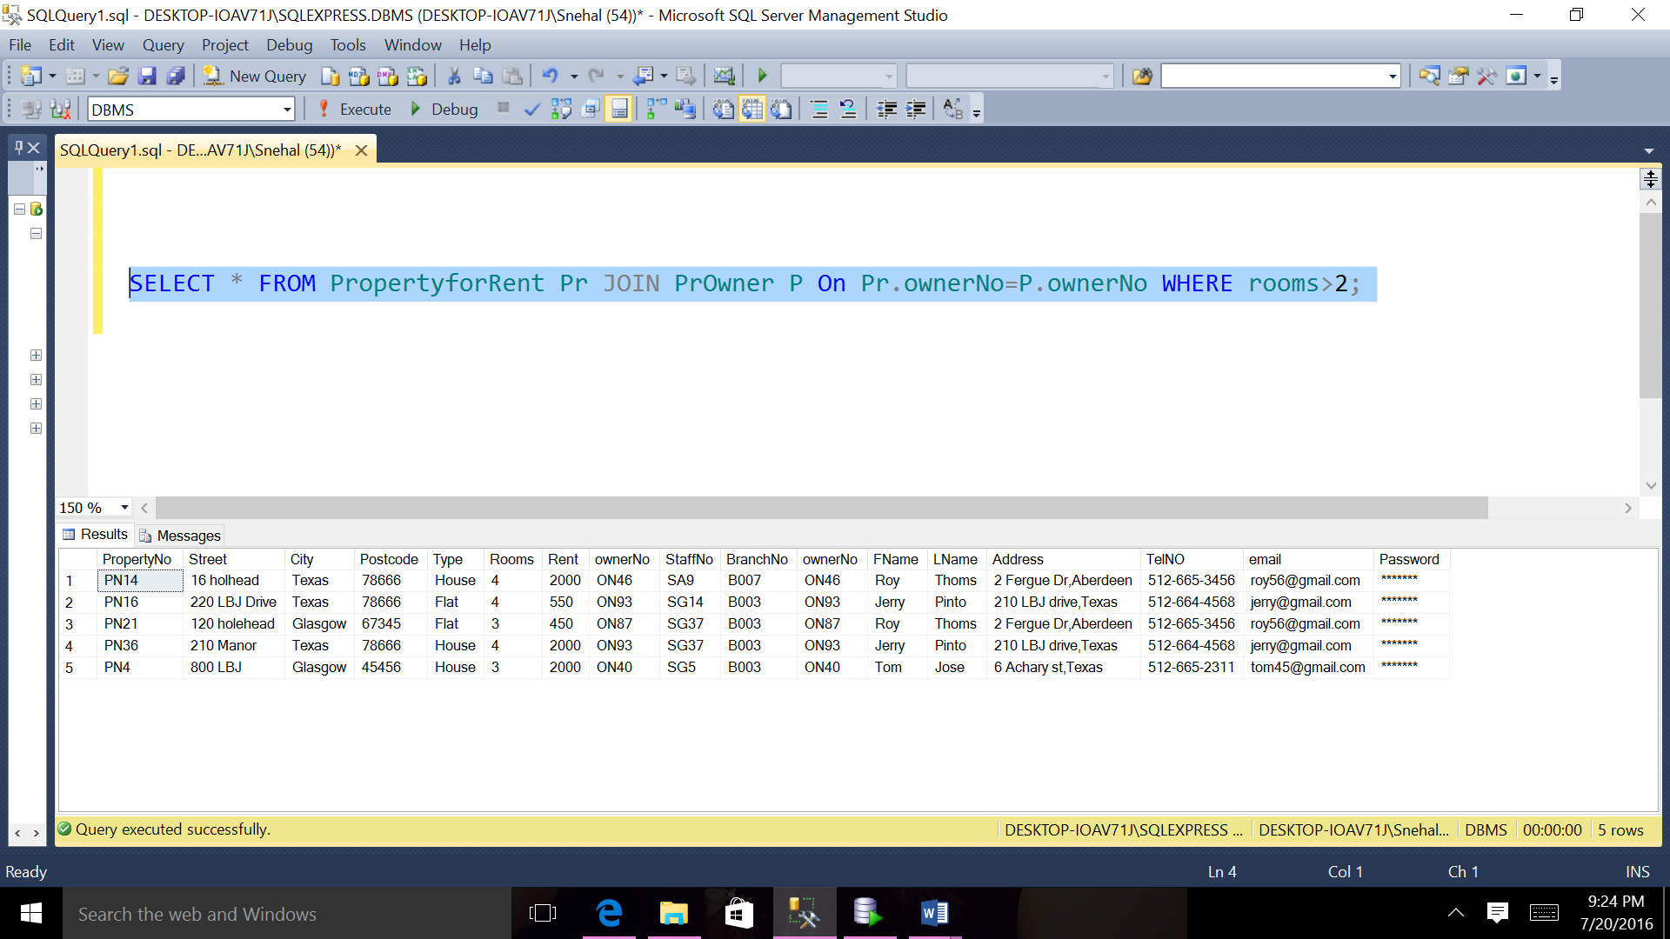

2)Select Telephone for all Branch who has Branch number B005.

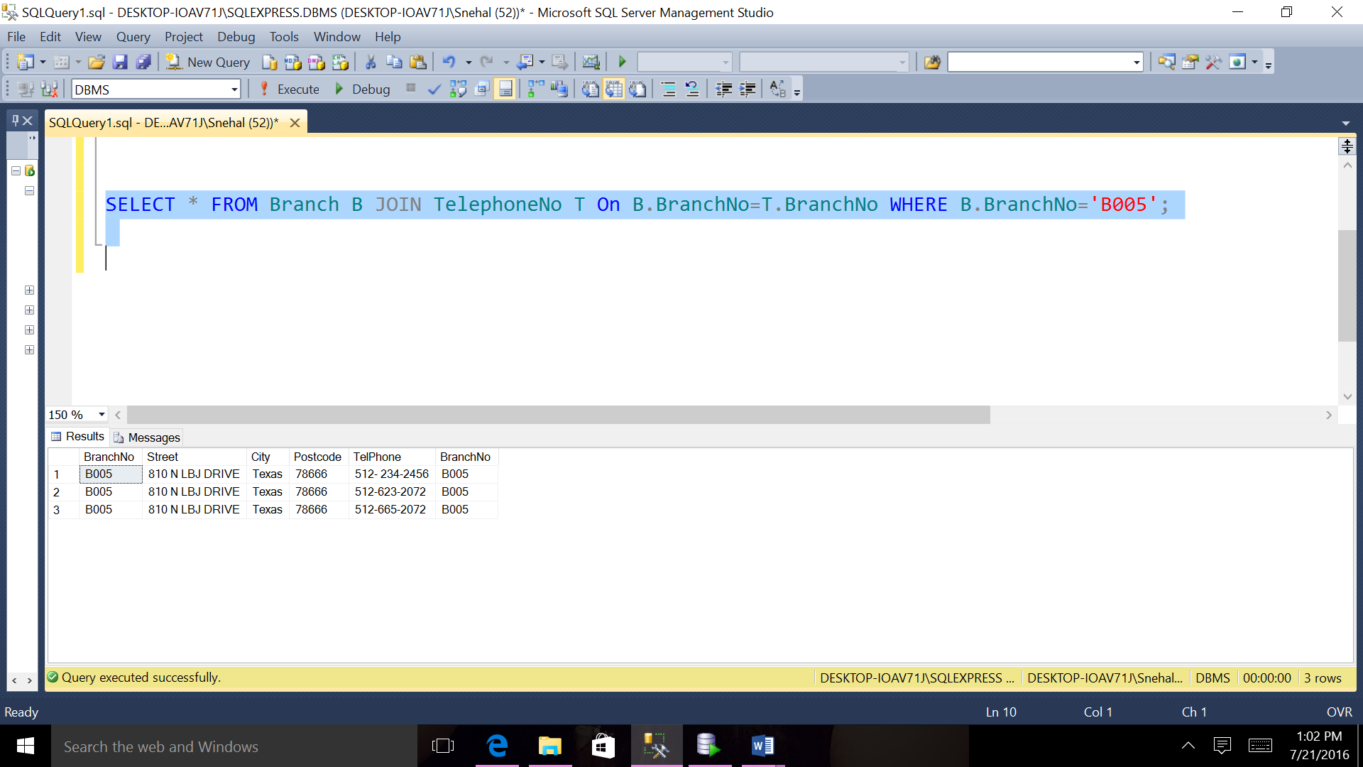

3)Select Viewing for all PropertyForRent where Property number is PN14 and Client Number is CN56.

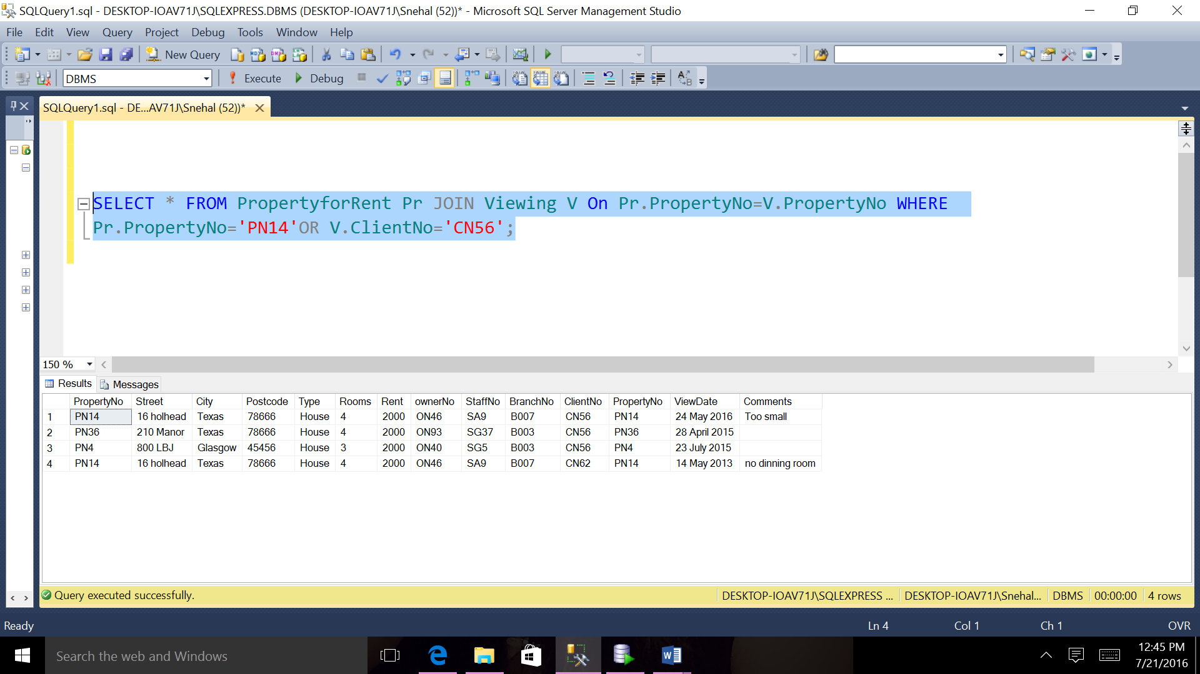

4)Select Branch number, city, Street from Branch and PropertyForRent order by Branch number.

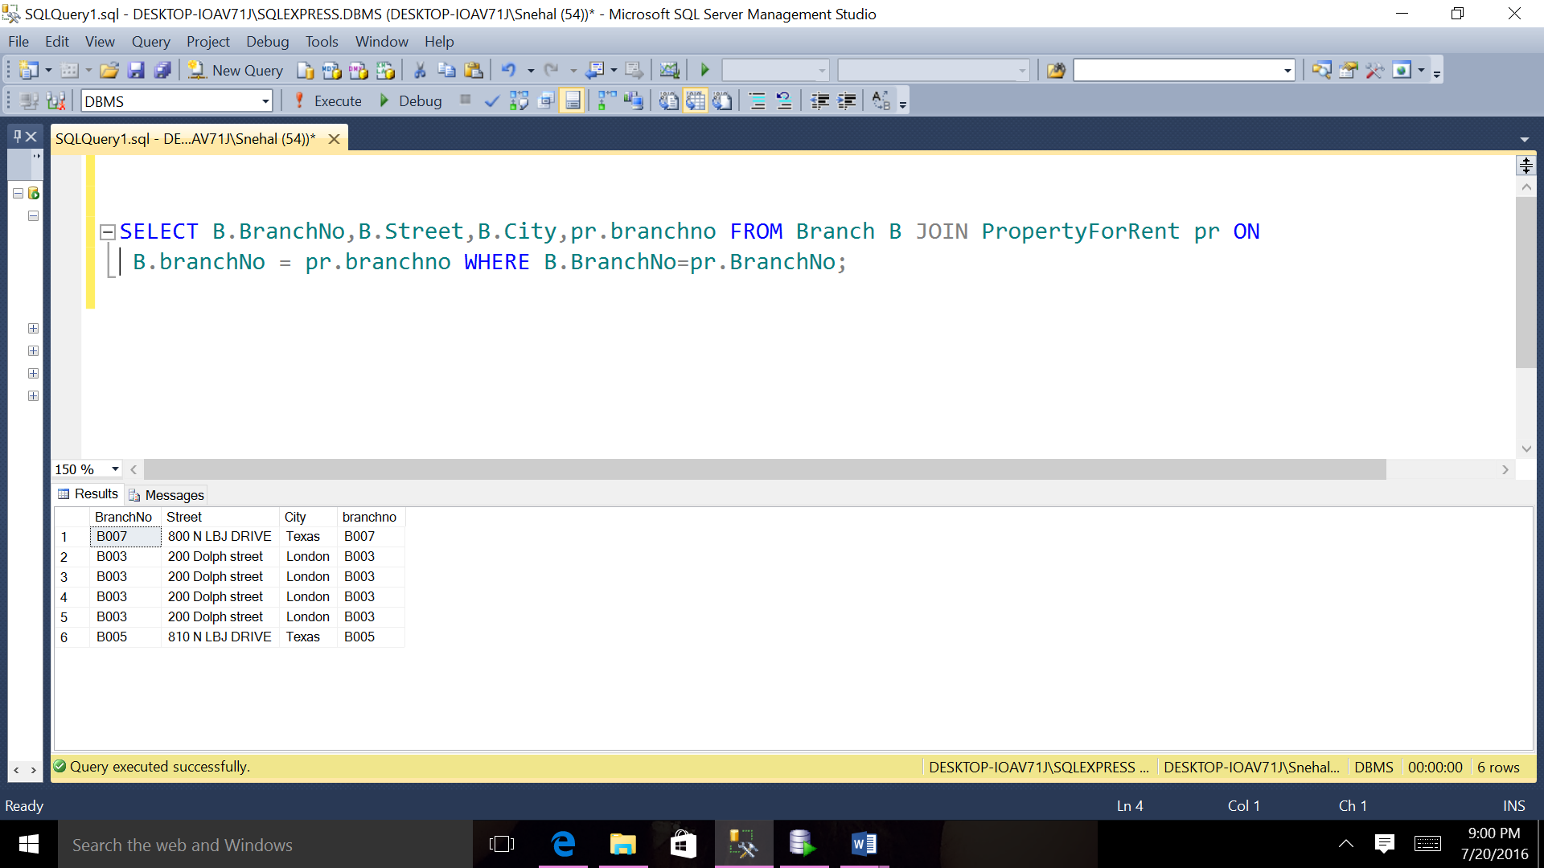

5)Select Owner number ,first name, last name ,Property number from PrOwer and PropertyForRent order by owner number .

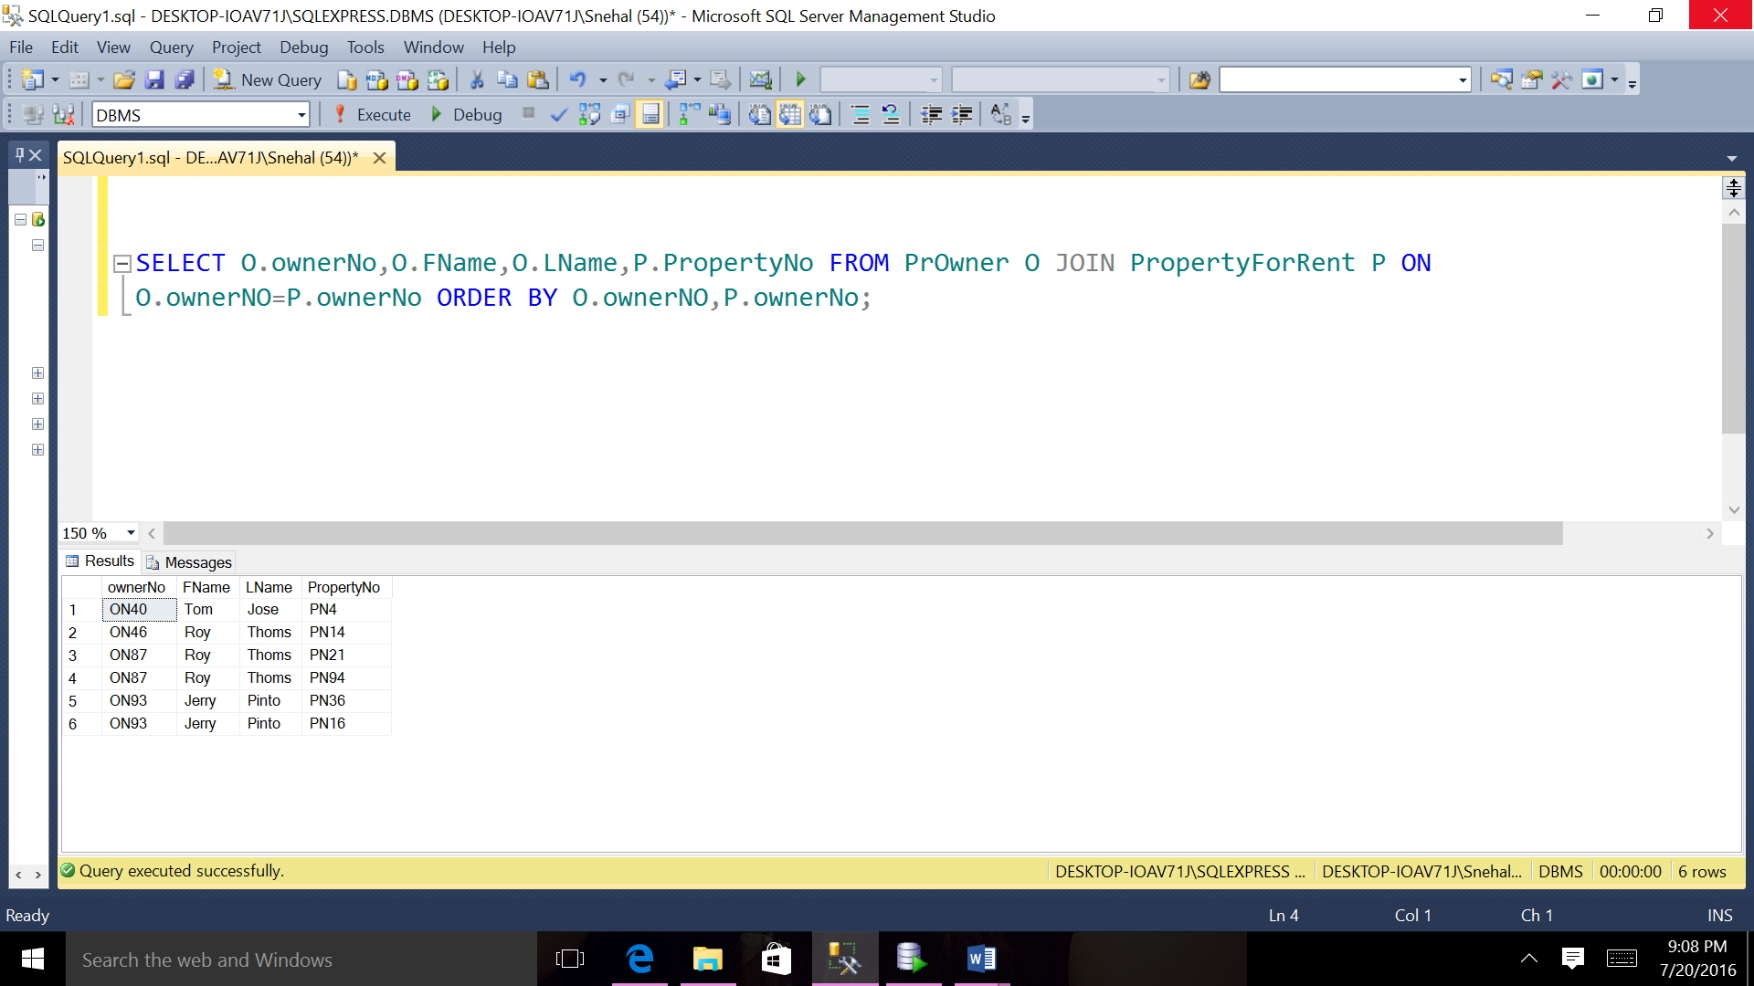

6)Select PrOwner for all PropertyForRent who has type flat.

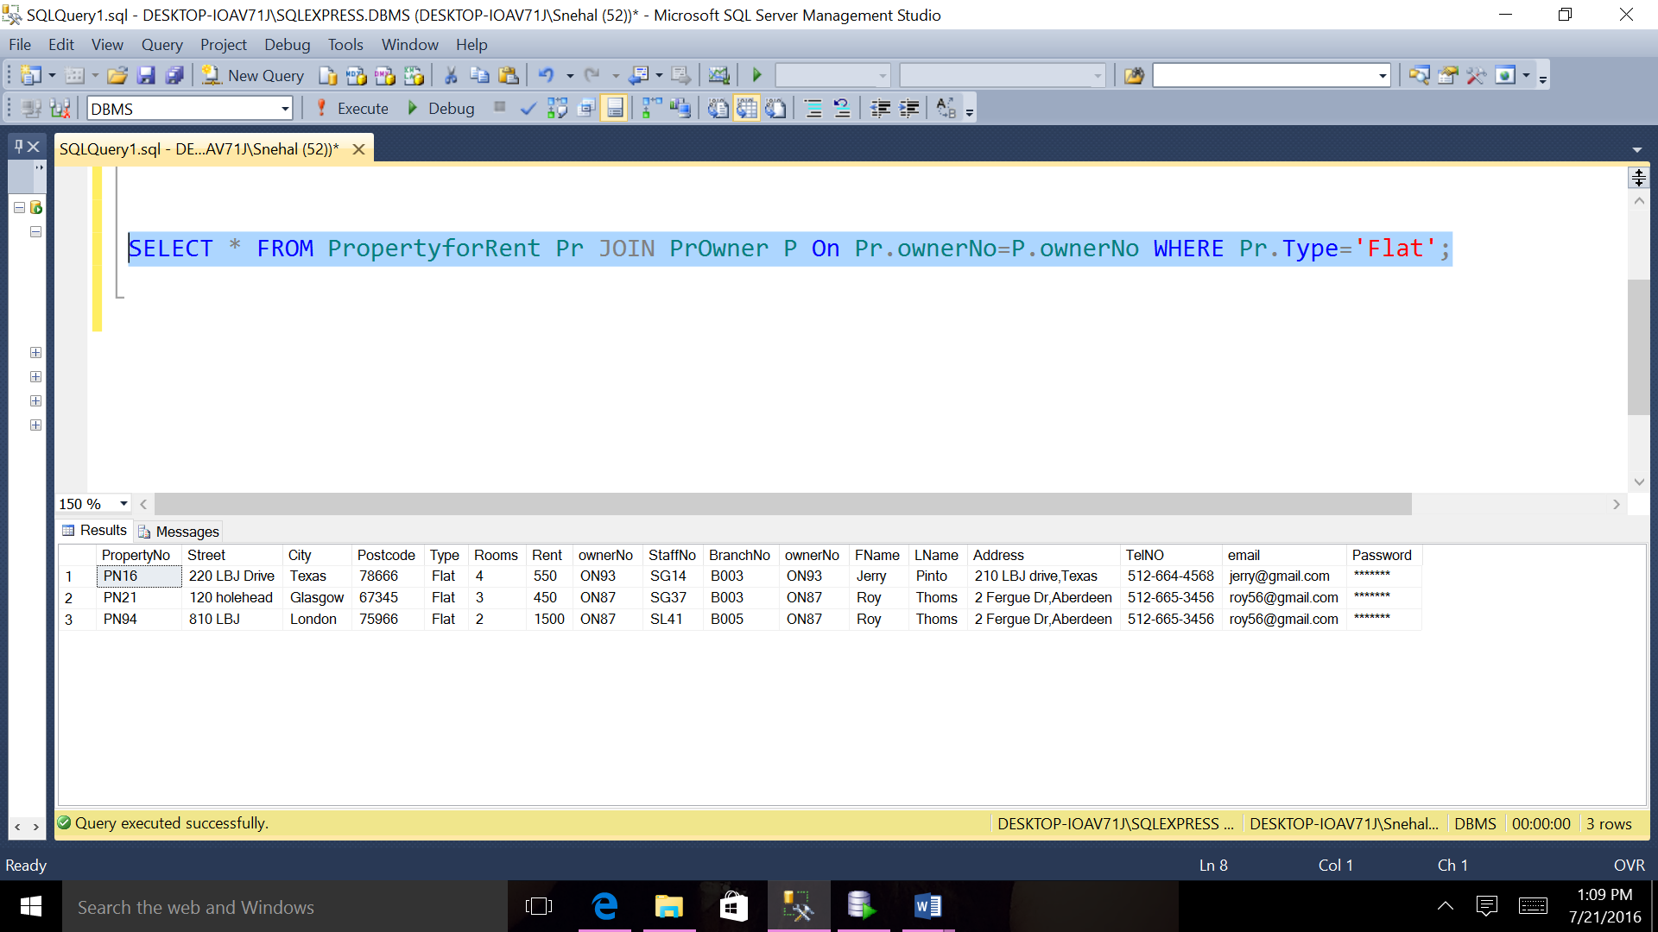

**ENTITY RELATIONAL DIAGRAM FOR DREAMHOME PROJECT**

